“Oberlin Baroque Performance Institute

The Wenzinger Years”



I’m not sure you will be able to open the previous image. It’s not vital so don’t try too hard.

Catharina Meints Caldwell wrote and produced this IBook to chronicle the history of the Baroque Performance Institute. BPI was created in 1972 by James Caldwell in order to bring famous Swiss musician, August Wenzinger, to the USA to perform, teach, and conduct. Catharina, who was closely involved with the beginnings of BPI, continues to be the senior faculty member 47 years later. She limited this memoir to the years 1972-1983 when Wenzinger was music director. Caldwell and Meints had preserved many of the administrative records and pictures, and these archives were an important source for gathering information and jogging memory.

August Wenzinger and Catharina Meints about 1974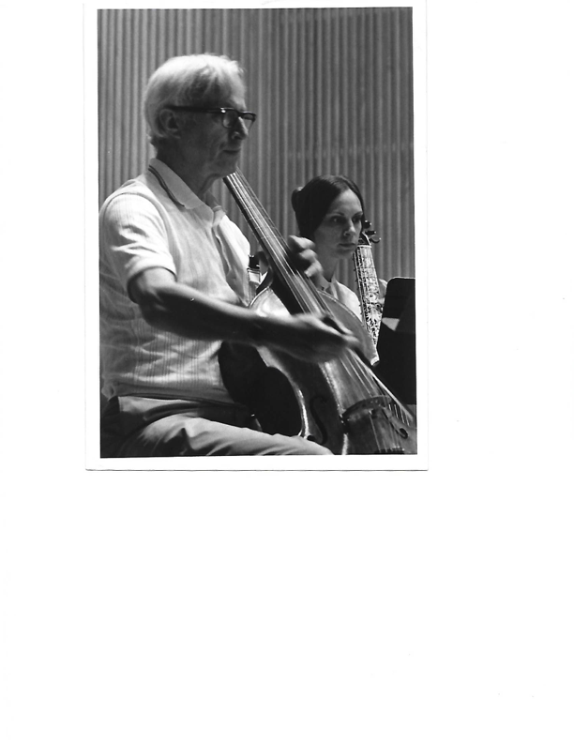

The book is available on IBooks.

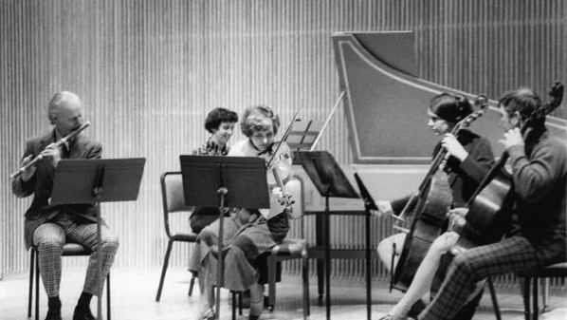The Oberlin Baroque Ensemble about 1975: Robert Willoughby, baroque flute, Lisa Crawford, harpsichord, Marilyn McDonald, baroque violin, Catharina Meints, James Caldwell, viola da gamba

The catalyst for this work was the unexpected opportunity to hear and preserve a number of recordings that the faculty made in the late 1970s that were never released. Others still existed on LP, but have not been reissued on CD. Meints was able to “embed” a number of tracks in the book but there was much more music to be heard. The equivalent of 16 CDs is now available on this website. The tracks have been arranged by national style, and are roughly chronological within each section.

???Is this where you make a link? I think the music list should be on another page and there should be a link there as well.